Tech Spec - Downtime Communication
Author/s: Sarthak Sharma
Team/Pod: Payouts Core | BU: RazorpayX
Published Date: Feb 2, 2024

Reviewer Name | Reviewed Date | Status
Payouts Core |  | In progress

Table of Contents

1. Problem Statement 2
2. Introduction & Scope 3
2.1. Relevant Resources 3
3. Out of Scope 3
4. Futuristic Scope 3
5. Assumptions, Goals & Non-Goals 3
5.1. Assumptions: 3
5.2. Goals: 3
5.3. Non-Goals: 4
6. Current Architecture / Current HLD 4
7. Final Approach - Specifications 4
7.1. List of Possible Solutions 4
7.2. Assumptions 4
7.3. Possibility of Open Sourcing 5
7.4. Possibility on Patent 5
7.5. Data model/Schema Changes 5
7.6. Business Logic Changes 5
7.7. Miscellaneous Questions 5
8. Non Functional Requirements (NFRs) 6
8.1. Scalability 6
8.2. Availability 6
8.3. Security 6
8.4. Compliance 6
8.5. Reliability 6
8.6. Infra Cost 6
9. Feature Dependencies & SLAs 6
9.1. Upstream Dependencies 6
9.2. Downstream Dependencies 6
10. Testing Plan 7
10.1. Test Cases 7
10.2. UAT Testing 7
10.3. Performance/Load testing 7
11. Go-live plan 7
11.1. Production Rollout and Ramp plan 7
11.2. Backward Compatibility 7
11.3. Rollback plan 7
12. Monitoring & Logging 8
13. Milestones & Timelines 8
14. Glossary 8
15. Appendix 8

💡Note

Read following docs to get expert on different topics -
- Format and Structure Your Doc
- How to document code in Google Doc
- API Design Guide
- Put Google Doc in Presentation Mode

Full Reading List - Link

1. Problem Statement
Currently we are not sending downtime communication to merchants which increases operational load on our customer support/PSE team to communicate downtimes manually to the merchant.
We are right now sending communication when we have fail-fast in our system. Fail fast triggers have a very high threshold which does not guarantee merchant communication during downtimes.

2. Introduction & Scope

The idea here is to send communication to merchants as per their requirement. Scope of this doc as follows:

- Send merchant communication as per their configured level of thresholds.
- Manual action to send communication for merchants
- Ops team/merchant should be able to whitelist merchants for downtime communication.
- Communication will only be done for instant modes

2.1. Relevant Resources
Link to Product Spec - Link

3. Out of Scope
Phase 1

- Mode Wise configs
- Merchants won’t be able subscribe to notifications via the merchant dashboard.

4. Futuristic Scope

5. Assumptions, Goals & Non-Goals

5.1. Assumptions

- Merchant will have on board the feature for getting downtime communication. For now it will be taken care of by the ops team to onboard merchants. This feature will be directly extended to the merchant via merchant dashboard to subscribe themselves for a downtime notification.

5.2. Goals
Goals are divided into phases as per timeline constraints.
Phase 1
- Send automated merchant communication for CA, MAR and lite merchants
- Template for each type of merchant should be different
- Do not bombard merchants with multiple notifications

Phase 2
- Set notification level as per channel and mode
- Create bulk action to onboard existing merchants
- Enable merchants to subscribe to partner bank downtime alerts
- Migrate merchant communication module to Payouts Service
- Have different tier/level available to the merchants

5.3. Non-Goals
Call out clearly the non-goals of the feature as well.
For instance, if the feature is important, we would be releasing it irrespective of the costs being incurred. Hence, it's not a goal but however, it's not out of scope.

6. Current Architecture / Current HLD

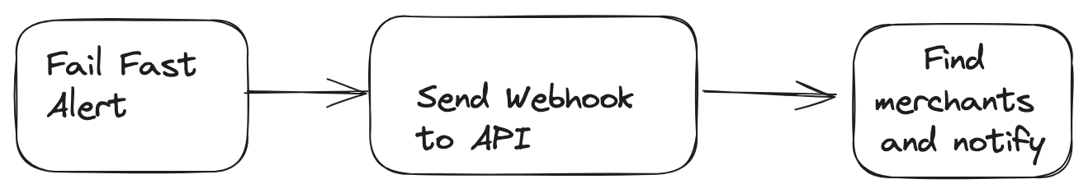

Problems with the current architecture -
1) Does not have notification tier for merchants
2) Notification configs are not created per mode and channel level
3) Fail fast alerts are very lenient due to which downtime notifications are not sent to the merchants as fail fast happens at a very high threshold. For eg for a channel and mode FR > 80%
4) Merchants cannot subscribe to specific alerts

7. Final Approach - Specifications

This section will highlight which approach is being picked up and why

7.1. List of Possible Solutions

Phase 1:

This section primarily focuses on CA merchant communication using existing design for fail fast triggers. Fail fast triggers will be removed and all merchant CA merchant communication will move to new downtime triggers. This is primarily taken up to make this feature available for CA merchants

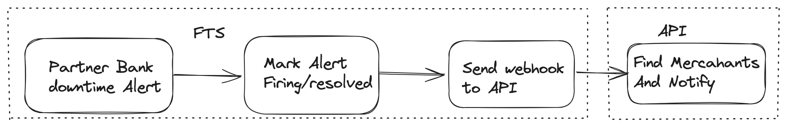

Pros :
- Easy and early release possible with the existing architecture.
- We will be able to test thresholds early
- Easily extensible to lite merchants as well
- Can be easily extended to lite merchants
- Will be able to set thresholds for number of alerts for each channel integration

Cons/Out of Scope:
- Existing config is not mode wise. By default merchants will be on boarded to both modes.
- Won’t be able to create different notification tier for merchants as mentioned in the product spec
- Merchants won’t be able subscribe to notifications via the merchant dashboard. Current processes in place will be followed.Currently ops team add merchants notification config.
- Pending Migration to PS

Phase 2

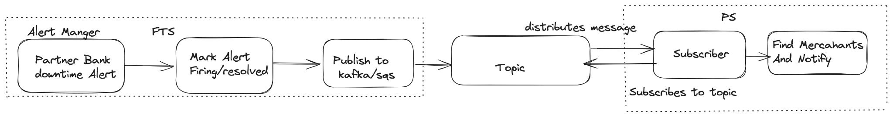

- Merchants can subscribe to partner bank downtime notification via dashboard
- Merchants will have the freedom to choose modes for partner bank downtime notification
- Migration of the module to Payouts Service.
- Merchants will have notification tier as per their requirement.

Pros:
- Loose coupling b/w modules.
- Guarantees message ordering and delivery
Cons
- Will take time to implement
- Payouts service does not have CA merchants information as of now. Will have to expose APIs to fetch such information.

7.2. Assumptions

7.3. Possibility of Open Sourcing

7.4. Possibility on Patent

7.5. Data model/Schema Changes

Phase 1
FTS table to store Partner bank downtime details -
Table - merchant_communication_details
id int(11) NOT NULL AUTO_INCREMENT,
channel_information_status_id int(11),
status enum(STARTED, RESOLVED),
notification_type enum( PARTNER_BANK_DOWNTIME, BENEFICIARY_BANK_DOWN)
notification_tier enum(AGGRESSIVE, DEFAULT, LENIENT),
count int(2) NOT NULL
created_at int(11) NOT NULL,
updated_at int(11) NOT NULL,
deleted_at int(11) NULL,
UNIQUE KEY merchant_communication_unique_key (id, channel_information_status_id, notification_type, notification_tier)
key merchant_communication_index (channel_information_status_id, notification_type, notification_tier)

Phase 2
Payouts table to store Merchant config

id char(14) CHARACTER SET utf8mb4 COLLATE utf8mb4_bin PRIMARY KEY
merchant_id char(14) CHARACTER SET utf8mb4 COLLATE utf8mb4_bin PRIMARY KEY
enabled bool
channel
mode
notification_type enum( PARTNER_BANK_DOWNTIME, BENEFICIARY_BANK_DOWN)
notification_tier enum(AGGRESSIVE, DEFAULT, LENIENT),
notification_email
notification_number
created_at int(11) NOT NULL,
updated_at int(11) NOT NULL,
deleted_at int(11) NULL,

7.6. Business Logic Changes
Phase 1
FTS

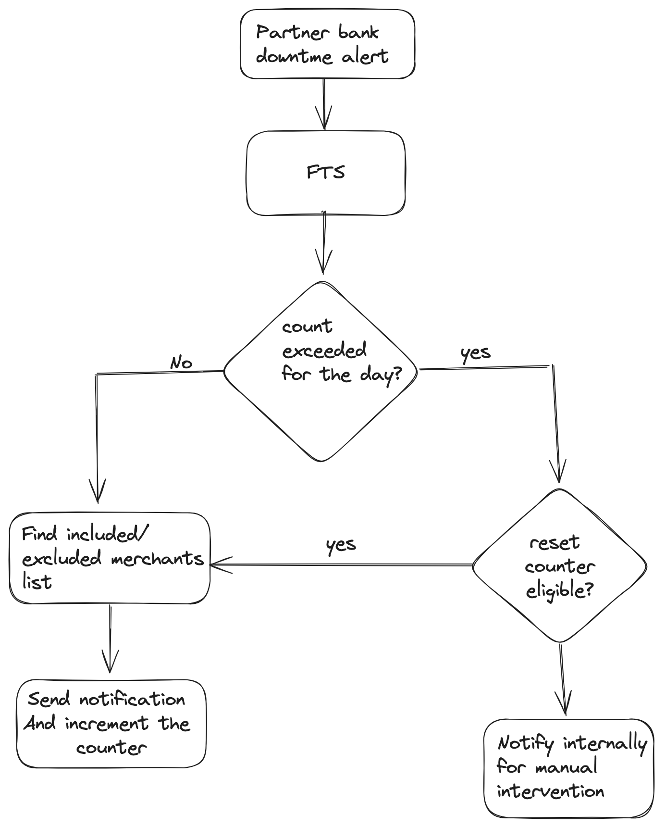

- We will have basic checks for enablement for each integration
- The schema mentioned above will be used to maintain counter for a specific alert

API

Payload Sent to API

[
type' => 'partner_bank_health',
'payload' => [
'begin' => 1640430729,
'instrument' => [
'bank' => 'RBL',
'integration_type' => 'direct'
],
'include_merchants' => ["ALL"],
'exclude_merchants' => [],
'source' => 'downtime',
'mode' => 'IMPS',
'status' => 'down/up',
],
],

- Existing code does not have an implementation for source `downtime`. We will use the same for partner bank downtime communication
  - Implementation remains the same as for the fail fast as it covers most of the areas.
- We have a template for downtime communication -
  - NameSpaces - razorpayx_payouts_core
  - Template_name - emails.partner_bank_health.{down/up}
- We will create another template for MAR merchants
  - Template_name - emails.partner_bank_health_mar.{down/up}
  - TBD : What email should be send if both channels are down

Alerts
Availability vs individual alerts for each trigger - Comparison to be done

Phase 2

List of API’s

- get-merchant-available-channels
  - This will return all direct/lite available for merchants for each mode
  - HTTP Method - GET
  - Response - {
"chanels" : {
"RBL" : {
active_modes: ["UPI", IMPS],
}

"lite" : {
active_modes: ["UPI", IMPS],
}
}

"notification" : "partner_bank_downtime",
"notification_tier" : ["Aggressive", "default", "lenient"],

}

- create-merchant-notification-config
  - HTTP method - POST
  - This API will be used to create/update the resource
  - Request
{
"chanels" :
{
"RBL" :
{
"UPI" :
{
"notification_type" : "partner_bank_downtime",
"notification_tier" : [default"],
"notification_email" : ["abc@gmail.com"],
}

}

"lite" :
{
"UPI" :
{
"notification_type" : "partner_bank_downtime",
"notification_tier" : [default"],
"notification_email" : ["abc@gmail.com"],
}
}
}

}
- get-merchant-subscribed-notification-details
  - HTTP method - GET
{
"chanels" :
{
"RBL" :
{
"UPI" :
{
"notification_type" : "partner_bank_downtime",
"notification_tier" : [default"],
"notification_email" : ["abc@gmail.com"],
}

}

"lite" :
{
"UPI" :
{
"notification_type" : "partner_bank_downtime",
"notification_tier" : [default"],
"notification_email" : ["abc@gmail.com"],
}
}
}

}
Note - This might change a bit as per the front end design. These are just initial thoughts as of now

- Queue changes - TBD
- Payouts Service Changes - TBD

7.7. Miscellaneous Questions
Answer questions if only relevant, add more questions as required
- What are the limitations of the solution?
- How will it recover in the event of a failure?
- How will it cope with future requirements?

8. Non Functional Requirements (NFRs)
Talk about each as applicable and call out the expectations/risks from the feature.

8.1. Scalability

8.2. Availability

8.3. Security

8.4. Compliance

8.5. Reliability

8.6. Infra Cost

9. Feature Dependencies & SLAs
Callout upstream and downstream applications that will get impacted

9.1. Upstream Dependencies
Add SLO/SLA dashboard links for existing services.
Sr. No. | Service | Impact | SLA (if applicable) | POC for service
1 | abc |  |  | Owner/expert on abc

9.2. Downstream Dependencies
Sr. No. | Service | Impact | SLA (if applicable) | POC for service
1 | xyz |  | TBD | Aditi Maheshwari

10. Testing Plan
Lay down test scenarios

10.1. Test Cases
(UTs, ITs, regression suites, UI/UX tests and manual test efforts)
Capturing the results with upstream and downstream applications and validating the results against expected outputs

Add links here only.

10.2. UAT Testing
Capturing User acceptance test results, validating against genuine data

10.3. Performance/Load testing
Capturing any load testing that we wish to perform

11. Go-live plan

TBD

11.1. Production Rollout and Ramp plan

11.2. Backward Compatibility

11.3. Rollback plan
Add what will be done in case of an immediate rollback requirement and how it will be implemented.

12. Monitoring & Logging
Jot down all metrics that need to be monitored for the changes being made

13. Milestones & Timelines
Breakdown the task into major milestone, divide the milestones to further task and subtask, mentioning owners, JIRA/Asana link, due date, reviewer, status
Creating a tabular sheet in excel is preferable here for better understanding
Please paste the link for the tracker with details similar to below here

Sr. No. | Title | Owner | JIRA/Asana link | Due Date | Reviewer | Status
1
2

14. Glossary

This section describes all the terms and abbreviations being used specifically in the context of the above feature and heavily being used in this document.

15. Appendix

This section provides the links to all other important documents such as Project Milestone trackers, PRDs (created by Product team), Concept notes, JIRA/Asana project links and any other relevant links.

- Razorpay Product: Concept Note Template <June 2022>
- https://stackoverflow.blog/2020/04/06/a-practical-guide-to-writing-technical-specs/
- https://www.thecloudtutorial.com/technical-specification-document/

